Client Intake Form
NAME _______________________________________________ DATE_________________
ADDRESS____________________________________________________________________
PHONE_____________________________ EMAIL__________________________________
DOB_____________ OCCUPATION______________________________________________
1. Have you had a professional massage before? Frequency?

2. Do you have any pain or difficulty lying on your front, back, or side?

3. Allergies to oils—lotions? nuts? latex? essential oils? fragrances? other?

4. Are you wearing contact lenses, dentures, hearing aids? Do you have any prosthetics, pacemaker, port, hardware (rod, ball/socket, plate, etc.)

4. Do you sit for long hours at a workstation, computer, or in a vehicle?

5. Do you perform repetitive movement in your work, sports, or hobby?

6. How is your stress level? How do you feel stress in your work, family, or other aspect of your life affects you? (circle all that apply): __muscle tension ___anxiety ___insomnia __ irritability ___other (specify):
7. Is there a particular area of the body where you are experiencing tension, stiffness, pain or other discomfort? You may indicate it on the following chart and/or in words.

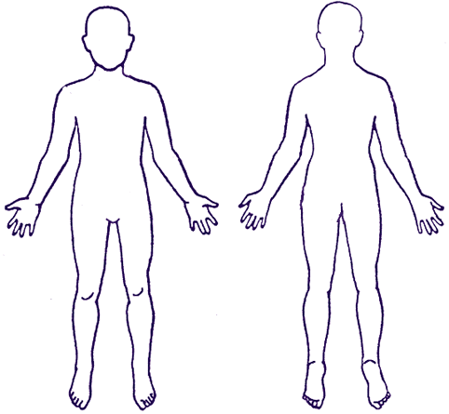
front back

8. Is there anything that makes the pain better?

worse?

9. Are you under medical supervision of an MD? A chiropractor? Physical Therapist? Massage Therapist? If so, who?

10. List current medications, vitamins, minerals, herbal supplements, essential oils you’re taking and what they are treating:

11. How often do you use alcohol, recreational drugs, tobacco, sodas? List kind and frequency.

12. Have you ever lived in an abusive situation at home or work? Experienced physical violence (child abuse, mugging, rape, etc.)? Or emotional abuse?

Note any current or past medical conditions and note with a C or P (current or past

Integumentary:  _____Boils  _____Fungal infections  _____Skin cancer  _____Eczema  _____Psoriasis  _____Herpes  _____Rash  _____Other  Musculoskeletal:  _____Fibromyalgia  _____Rheumatoid arthritis  _____Osteoarthritis  _____Tendonitis  _____Bursitis  _____Osteopenia/Osteoporosis  _____Headaches  _____Scoliosis  _____Whiplash  _____Carpal Tunnel  _____Strains/sprains  _____Plantar fasciitis  _____Concussion  _____Flat feet or high arch  _____Tennis/golf elbow  _____Artificial joint(s)  _____Rotator cuff injury  _____Rib fracture/injury  _____Fracture within past year  _____Other  Nervous:  _____Decreased sensation  _____Learning disability  _____Autism spectrum  _____Seizure disorder  _____Multiple Sclerosis  _____Migraine Headaches  _____Mood disorder (depression/bi-polar)  _____Stroke  Other:  _____Cancer  _____Diabetes  _____Hypoglycemia  _____HIV/AIDS  _____Thyroid  _____Pituitary  _____TMJ Dysfunction  _____Tinnitus  _____Pressure behind eyes  _____Jaw locks open  _____Jaw pops | Digestive:  _____Cirrhosis  _____Ulcers  _____Diverticulitis  _____Hepatitis  _____GERD  _____Hernia  _____Irritable bowel syndrome  _____Crohn’s disease  _____Kidney stones  _____Gall stones  _____Troublesome constipation/diarrhea  _____Other  Respiratory:  _____Asthma  _____Emphysema  _____Sinusitis  _____Tuberculosis  _____COPD  _____Chronic ear infections  _____Respiratory infections  _____Allergies  Circulatory:  _____Anemia  _____Heart disease  _____Blood pressure high or low  _____Varicose veins  _____Clotting disorder  _____High cholesterol  _____Bruise easily  _____Swollen feet  _____Reynaud’s syndrome  Reproductive:  _____Breast cancer  _____Lactation problems  _____Prostate cancer  _____Endometriosis  _____Ovarian cysts  _____PMS  _____Peri- or Menopausal  _____Pregnant?  if C--how many months?  if P—how many times?  _____How many births?

List accidents--car, falls (on ice, down stairs, etc.), sports injuries, blows to head, childhood incidents (bike wrecks, sledding accidents, falling out of a tree, etc.)

List all surgeries, including dental surgeries (continue on back, if needed)

Please note any other information you feel your therapist needs to know or that will be helpful
in treating you.

In the unlikely event of an emergency, please list two emergency contacts with names and numbers.

Because massage should not be performed under certain medical conditions, I affirm that I have stated all my known medical conditions, and answered all questions honestly and completely, to the best of my knowledge. I agree to keep the therapist updated as to any changes in my medical profile, and I release the therapist of any liability if I fail to do so.

_____________________________________________________________________________
Signed Date

INFORMED CONSENT FOR MASSAGE THERAPY TREATMENT

I understand that the massage services are intended to promote relaxation and circulation and to relieve stress, muscle tension, spasms, and related pain. I understand that massage should not be construed as a substitute for medical examination, diagnosis, or treatment and that I should see a physician other qualified medical specialist for any physical ailment that I am aware of. I further understand that massage therapists are not qualified to perform adjustments, diagnose, prescribe, or treat any physical or mental illness, and that nothing said in the course of the session should be construed as such.

I understand that my therapist cannot guarantee exactly how my body will respond to any treatment.

If I experience any pain or discomfort during massage sessions, I will immediately inform the therapist so that the pressure and/or strokes may be adjusted to my level of comfort.

I understand that any illicit or sexually suggestive remarks or advances will result in immediate termination of the session and that I will nonetheless be responsible to pay for the whole time scheduled. Police may be summoned and charges pressed.

I understand that the therapist reserves the right to refuse to perform massage on anyone whom she deems to have a condition for which massage is contraindicated. This includes a communicable disease, a fever, and the recent use of alcohol or recreational drugs.

If I have a cold or feel like I’m getting sick, I will cancel the session in as timely a manner as possible.

I understand that all information and anything said in my session will be kept confidential, although I also understand that, as medical providers, massage therapists are required by law to report any evidence of abuse of those under others’ care. Adults who are free to leave abusive situations will receive utmost confidentiality and care.

I understand that I have the right to know and should ask about any treatments I am receiving. I may withdraw my consent at any time and treatment will be stopped or modified with my consent.

By signing this form, I consent to being treated with massage therapy, including such assessments, examinations and techniques that may be recommended by my therapist.

I have read this consent form and have had the opportunity to question its contents.

Client Name (Printed)__________________________________________________________

Client Signature _____________________________________________________________

LMT signature___________________________________ Date Signed:____________________

